**Brooklyn torah gazette**

**For parshas vayakhel 5782**

Volume 6, Issue 23 (Whole Number 278) 25 Adar I 5782/ February 26, 2022

*Reprinted from the Parshat Tissa 5757/1997 edition of L’Chaim. Adapted from Vedibarta Bam by Rabbi Moshe Bogomilsky.*

**Why Is There Antisemitism?**

**By Rabi**[**Aron Moss**](https://www.chabad.org/search/keyword_cdo/kid/8051/jewish/Moss-Aron.htm)



**Illustration by Sefira Lightstone**

It seems like anti-Semitism is everywhere these days, and almost becoming acceptable again. Why do so many people hate Jews? Why is anti-Semitism still flourishing today, even in modern society? And what can we do about it?

**Answer:** The deepest analysis of anti-Semitism can be found in a deceptively simple Talmudic passage discussing the Purim story, and its wisdom still rings true today.

Haman was an anti-Semitic minister in ancient Persia who wanted to see the Jews annihilated. He approached King Ahasuerus and offered to pay him a hefty sum in return for permission to fulfill his vile wish. The King responded, “Keep your money and do with the Jews as you please!”

**The Talmud uses a parable to explain the king’s response:**

A farmer had a problem. There was a big mound of dirt in the middle of his field. His neighbor had a different problem, he had a ditch in the middle of his field. The owner of the ditch saw the mound and thought, “I would pay money for his mound to fill my ditch.” The owner of the mound thought, “I would pay money to get rid of my mound in his ditch.” The two finally met, and the ditch owner asked to buy the mound. The mound owner said, “Please take it for free!”

In the same vein, when Haman offered to pay Ahasuerus to rid his kingdom of Jews, the king said, “Go ahead! No need to pay.” Ahasuerus saw the Jews as a mound sticking out in his kingdom, but what Haman saw was a hollow ditch, a deep hole.

**And that is the story of anti-Semitism.**

Ahasuerus and Haman represent two layers of hatred, the conscious and the subconscious. On the surface, anti-Semites hate Jews because they are a mound. But deep down, they hate Jews because they hate the ditch.

Anti-Semites make all sorts of contradictory statements about why they hate Jews. Jews are rich and own everything, or Jews are poor and stateless; they are religious extremists or they are secular cosmopolitans; they assimilate or they stay separate. Jew-haters say, “Go back to Israel!” and they say, “Get out of Palestine!” They say, “The Nazis should have finished the job,” and they say, “The Holocaust never happened.”

All of these accusations are really saying the same thing: the Jews are a mound in our field. You are in the way. You don't belong here. You are an obstacle, an eye-sore, a blot on humanity. But these are all just pretexts and excuses. None of these is the real reason for anti-Semitism. The true cause of anti-Semitism is not the mound, it is the ditch.

At their core, those who hate others actually hate themselves. Beneath their macho exteriors lies a profound emptiness, a vacuous hole in their souls. They subconsciously sense that their ideology is false, their beliefs empty, their lives void of meaning. And when you are empty, you hate those who are full. When you lack meaning, you envy those who have it. And there is no people that represents higher purpose and eternal truth than the Jewish people.

This is why there are anti-Semites who have never even met a Jew. It's nothing personal. Their hatred is a symptom of their anger at themselves, which they refuse to face, so they project it on another. And the ultimate other is the Jew, the eternal Jew who has watched civilizations come and go, who has outlived all the ditch owners that tried to wipe him out.

In every generation there are evil ideologies. They take on various facades, but they share one common feature: they all hate the Jews. If you want to know which ideology is the destructive force of the age, look at the ones that embrace anti-Semitism. No matter how cultured and intelligent they look, at their core lies a nihilistic ditch, and they are dangerous.

So, what should Jews do about anti-Semitism? What can anyone do about someone else’s existential emptiness?

**Taking Our Cues from the Purim Story**

We take our cues from the [Purim](https://www.chabad.org/holidays/purim/default_cdo/jewish/Purim.htm) story. The Jews of the time, under threat of annihilation, did not become less Jewish, but more so. We don't fight emptiness by becoming more empty and we don't make someone else’s problem into our problem. In the face of irrational hate, we stay proudly and defiantly Jewish, trusting in G‑d, and loyal to our people.

But the Jews of Persia also took political and military measures to protect themselves. Because while we hope that all those haters will one day find some meaning to fill their void, we will not sit by and be victims of those who haven't.

Haman never filled his ditch. But he gave us Purim. Every year Jewish children celebrate and make noise when they hear Haman’s name read in the Megillah. Because we won't be swallowed into somebody else’s dark ditch. We will continue to fight evil and emptiness, by bringing more light to the world.

*Sources:*

[Talmud](https://www.chabad.org/library/article_cdo/aid/2537389/jewish/Talmud.htm) [Megillah](https://www.chabad.org/library/bible_cdo/aid/15782/jewish/Esther.htm) 14a

The Lubavitcher Rebbe, Sichot Kodesh Purim 5725

**Thoughts that Count for Our Parsha**

*You shall not kindle fire in any of your dwellings on the Sabbath day.* (Exod. 35:3)

The Torah singles out this prohibition and not any of the other 39 major forbidden activities of Shabbat. Heated arguments are like fire. They can destroy families, homes, and relationships. When a person is busy there is no time for fighting, but because Shabbat is a day of rest, the Torah warns us not to kindle the "fire of dispute," and instead occupy ourselves with Torah study and prayer. *(Sha'lah)*

*Reprinted from the Parshat Vayakhel 5757/1997 edition of L’Chaim. Adapted from Vedibarta Bam by Rabbi Moshe Bogomilsky*

**Rav Avigdor Miller on**

**When Not to Blame Hashem**



**QUESTION:** **I was listening to one of your lectures and you said that everything comes from Hashem; that Hashem is paying you back for something. And then you quoted the sages that the only thing that doesn’t come from Hashem is the common cold. Can you explain that?**

**ANSWER:** This gentleman is quoting me as saying that the common cold is not from Hashem. And he wants to know why is it that the common cold is the only thing that does not come from Hashem.

Now we have to qualify that statement. It’s not only the common cold. All the things that a person causes by his own negligence to himself are his own doing.  Let’s say if a man walks up to this wall.  He walks from here and makes a charge with his head against the wall and he has a headache tonight. So, this man is lying in bed and his head is throbbing and he’s thinking, “Mah zos asah Elokim lanu? Why has Hashem brought this upon me? For what sin did this come to me?”

It’s a good question. And the answer is for the sin of butting your head against the wall. And that’s a big sin.

So, if a man is lying in bed with a cold and he’s thinking about what he did to deserve this — and he should think! — but the first of all things, before he thinks about any other thing, he should think, “Did I go out without a jacket? Did I go to sleep too late last night so I lowered my resistance.  I could have gone to bed on time but I was looking in the newspaper until too late at night and in the morning, I woke up and I didn’t have any energy and therefore when the germs started floating in the air on an airplane of a piece of dust and I breathed it in so my mucous membrane had been breached because my resistance was lowered.  And that’s why the cold germs found a nest in my throat.” That’s number one. That’s the first thing to think about when you get sick.

So why blame Hakodosh Boruch Hu for what you did? Is that clear now?

*Reprinted from the February 13, 2020 email of Toras Avigdor. Adapted from Tape #13.*

**More Thoughts that Count For this Week’s Parsha**

*Moshe gathered the entire assembly of the Children of Israel and said to them, "These are the things that G-d commanded, to do them*." (Exod. 35:1)

The words "to do them" appear to be superfluous. Moshe made a "convention" of the Jews. Sometimes a convention will consist of speeches and thoughts which do not necessarily lead to concrete results. G-d commanded Moshe to ensure that the thoughts and resolutions shared at this convention were brought down to practical results.

*Six days work shall be done and the seventh day shall be holy, a Sabbath of rest to G-d.* (Exod. 35:2)

Man was created to work (Job 5:7), yet here it talks of work in the passive form, "work shall be done," rather than in the active form, "You shall do work."

The Torah is in favor of people working, but is against the entire mind, heart, and soul being preoccupied with work. Therefore, during the week "work shall be done," but one's primary preoccupation should be Torah and mitzvot. *(Likutei Sichot)*

*They brought additional donations each morning.* (Exod. 36:3)

This is talking about the people who worked on the Tabernacle. According to Jewish law, the working day starts at sunrise and ends at night when the stars appear. For the building of the Tabernacle, the workers gave an extra donation of their time. They woke up especially early in the morning so that they would have more time to work during the day. *(P'ninim Yekarim)*

*Reprinted from the Parshat Vayakhel 5757/1997 edition of L’Chaim. Adapted from Vedibarta Bam by Rabbi Moshe Bogomilsky*

**The First Rabbi in America: Rabbi Abraham Rice Part 4**

**By Dr. Yitzchok Levine**

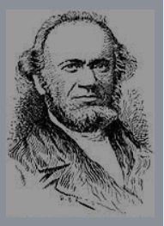

**The Lloyd Street Synagogue**

Rabbi Rice was instrumental in the building of what became known as the Lloyd Street Synagogue. Completed in 1845, it was the first Jewish house of worship built in Maryland.

Isaac Leeser, who was present at the synagogue’s dedication, described in detail the synagogue as well as the dedication ceremonies. He wrote in part: We will merely state for the information of our readers who doubtlessly feel an interest in the completion of the first house ever erected especially for our worship in Maryland, that its Eastern Front is ornamental with a Doric portico, through which is the entrance into the main building.

A flight of steps on each side leads into the gallery which runs along the west, north and south sides. The main body is divided into two aisles, furnished with pews, in place of open seats, which struck us as something unusual in our Synagogues.

The ark is a semi-circle, reached by a flight of steps of the same form, on the plan of the Synagogues in New York. Over the ark is a circular window laid out in the shape of the so-called “Shield of David” [Magen Dovid] furnished with colored glass of various tints.

The synagogue contained a mikveh as well as an oven for baking matzos.

**Problems, Resignation, and Return** The new synagogue proved to be both a blessing and a “curse.” It attracted people who were influenced by the Reform movement.

At first these people demanded some minor innovations, but, as time went on, they pushed for more and more changes.

There were constant conflicts and dissensions. Rabbi Rice refused to compromise when it came to halacha. He viewed minor attempts to introduce ritual changes as the first steps on the path towards a total break with Orthodoxy, and he was not wrong.

In 1849, things got so bad that, much to the shock of many synagogue members, he resigned as the spiritual leader of the congregation.

“‘I resigned’ he said, ‘because as a private citizen I expect to have greater influence with my Congregation. And,’ he continued, ‘I shall always be ready to fight the battle of the L-rd.’”

Despite the fact that Rabbi Rice no longer held a formal rabbinical position, he continued to have considerable influence over Baltimore Jewish life due to his religious scholarship and piety.

**Led a Small Congregation**

In 1851 he organized a small Congregation where he officiated as Rabbi and Chazan without compensation and where he felt spiritually at home. The group consisted of a number of pious and learned people who venerated their teacher and appreciated his piety and his dedication to the study of Torah.” In 1862, the Baltimore Hebrew Congregation found itself without a rabbi, and Rav Rice was asked to again become its spiritual leader. He agreed but refused half of the $1,000 yearly salary the congregation offered him. Unfortunately, he did not serve for very long in this position, since he passed away on October 29, 1862.

**His Legacy**

Notwithstanding the views of the narrow-minded and the bigoted, Abraham Rice’s place in the history of American Judaism is secure. The courage and dauntlessness with which he defended the principles of historic Judaism give him a unique place among the pioneers of Orthodoxy in America.

His consistent and uncompromising stand in matters of Jewish theology were the strongest factor in stemming the tide of Reform. His devotion to the study of Torah and his depth of talmudic learning made it possible for halachic Judaism to gain a foothold on American soil, where for centuries Jewish life was spiritually barren and Torah-less.

His dedication to Jewish education and his personal instruction of many a youth in this community were responsible for a new generation of enlightened laymen to be raised up who changed the entire physiognomy and religious climate of the Jewish community of Baltimore." (wherewhatwhen.com) These articles are based on two articles that originally appeared in The Jewish Press.

*Reprinted from the Parshas Ki Sisa 5782 email of whY I Matter, Yedidye Hirtenfeld’s parsha sheet for the Young Israel of Midwood in Brooklyn.*

**Recognizing that It’s Not Up to**

**Man, but to G-d to Have One’s**

**Work Done in Six Days**

**From the Talks of the Lubavitcher Rebbe**

**Rabbi Menachem Mendel Schneerson, Zt”l**

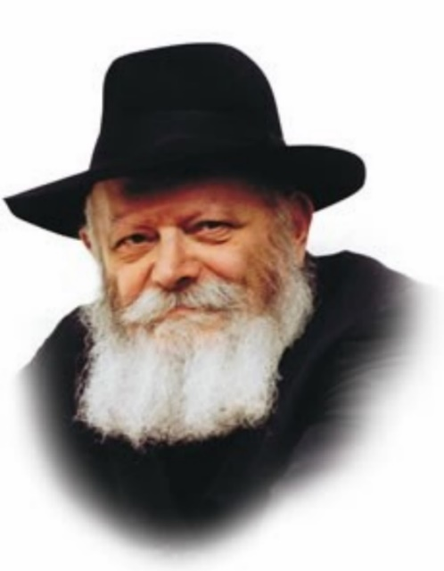

In the beginning of this week's portion, Vayakhel, Moshe relates G-d's command to the Jewish people: "Six days shall work be done, and the seventh day shall be holy, a Sabbath of rest to G-d."

In order to observe Shabbat properly, in accordance with G-d's command, the groundwork must first be laid by the six days of the work week: "Six days shall work be done."

**One Need Not Work Excessively**

Significantly, the commandment is not "Six days shall you do work." The verse does not instruct us to toil laboriously. "Six days shall work be done" -- as if the work is being done by itself. You needn't exert undue effort or invest too much of your energy, the Torah tells us. Rather, your work will be accomplished with a minimal amount of exertion.

This is a special blessing which G-d has bestowed on the Jewish people. Our Sages state, "When Israel does the work of G-d [when they serve Him properly], their work will be done by others." Not "Six days shall you do work," but "Six days shall work be done." Their work will already be completed.

This contains a lesson for every Jew to apply in their daily life. Yes, a Jew is obligated to work for a living, to provide for the members of his family, but only his most external powers and abilities should be invested toward this end.

It states in Psalms (128:2): "You shall eat the labor of your hands; happy shall you be, and it shall be good for you." When is it good for man? When only his "hands" are involved in his work; when his head and his heart, his thoughts and emotions, are reserved for higher matters: the study of Torah and the performance of mitzvot.

**Man Becomes Rich from G-d’s Blessing**

A Jew must never invest himself totally in his business affairs. For it is "the blessing of G-d that makes a man rich." A person's success is not determined by the amount of effort he puts into it. His efforts only create the vessel through which G-d bestows blessings. Thus, a Jew must reserve his intellect and energy for spiritual matters, while his business must be viewed as if it is taking care of itself.

Approaching work in such a manner ensures that the Shabbat will be observed properly, that the Jew will be able to put aside his material concerns on the day of rest. If a Jew is overly preoccupied with his livelihood during the work week, his Shabbat will be disturbed by worry and anxiety: How can he earn more money? What should he buy and sell? On Shabbat he will find it difficult to disconnect from worldly matters. Thus "Six days shall work be done" is the most appropriate preparation for "the seventh day shall be holy."

In this manner all the days of the week will acquire a Shabbat-like quality, and the Shabbat itself will have an increased measure of holiness, as implied by the Torah's repetition, "Shabbat Shabbaton -- a Shabbat of rest."

*Reprinted from the Parshat Vayakhel 5757/1997 edition of L’Chaim. Adapted from Likutei Sichot Vol 1.*

**The Shtadlan in Jewish History: A Conversation**

**With Dr. Henry Abramson**

**By Faigy Grunfeld**

[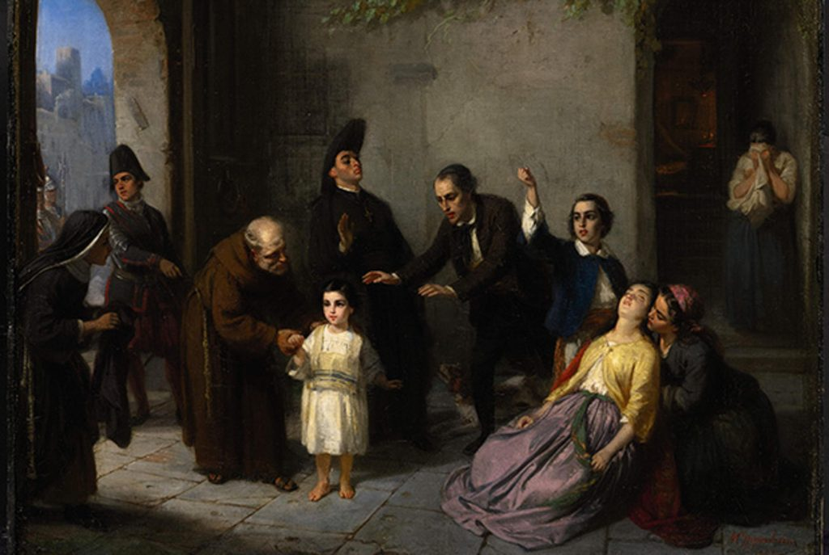](https://jewishaction.com/content/uploads/2021/11/MNP1WT-scaled.jpg)

**The Kidnapping of Edgardo Mortara by Moritz Daniel Oppenheim, 1862. The painting depicts the Italian Jewish boy who was seized by the Church to be raised as a Catholic. His mother is seen here fainting from distress. Illustration: Alamy Stock Photo**

Jewish Action writer Faigy Grunfeld discusses the role of the shtadlan throughout Jewish history with Dr. Henry Abramson. The academic dean of Touro’s Lander College of Arts and Sciences, Dr. Abramson holds a PhD in history from the University of Toronto and is a specialist in Jewish history and thought.

**Faigy Grunfeld: Let’s start with a definition of shtadlanut. Can you give us a brief historical overview of the concept?**



**Dr. Henry Abramson**

**Dr. Henry Abramson:** The term shtadlanut (from the Hebrew lehishtadel, to attempt, to try) is often translated as “intercession” and refers to efforts expended by a well-connected Jewish figure to influence public policy on behalf of the larger Jewish community.

**13th Century Reference**

The earliest historical reference to the term shtadlan in this context comes from thirteenth-century Spain, but the phenomenon dates back to antiquity. It is certainly a phenomenon most closely related to the minority status of Jewish populations in pre-democratic societies, although in our times the concept of a “lobbyist” comes close.

A shtadlan was especially valuable in societies governed by capricious rulers seeking financial support for various undertakings, such as foreign wars, who had to contend with rival power sources like the Church or an emerging noble class. The shtadlan, typically a charismatic, wealthy individual with strong skills as a culture-broker, advocated for the protection and advancement of the larger Jewish community with a combination of smooth talk and the promise of financial reward through general expansion of the economy, or even direct financial reward (“contributions,” i.e., bribes).

**An Effective Communal Term**

The last two millennia have amply demonstrated that Jews cannot simply rely on the benevolence of host populations. Shtadlanut emerged as an effective communal tool, one of the many tactics that allowed for the miraculous survival of the Jewish people in often very hostile cultural environments.

The strategy of shtadlanut is not perfect, and it has proven less valuable at certain times—the Nazis, for example, were almost impervious to the efforts of shtadlanut—but in a modified form it still plays a valuable role anywhere that Jews are a minority.

**FG: Where do you see shtadlanut originating? Does the reish galuta [exilarch, or head of the Jews in exile] in ancient Babylon loosely encompass the idea of a shtadlan? What about the medieval parnas?**

**DHA:**The earliest Biblical precedent might be someone like Yosef Hatzaddik, whose elevation to power by the Egyptian pharaoh afforded him the authority to protect the migrant Hebrews in the land of Goshen. We see similar patterns expressed in the careers of other Diaspora figures like Daniel and Esther, whose intercession on behalf of the Jewish community was directly salvific and celebrated for centuries afterward.

**Several Distinctive Types**

In the post-Biblical period, several distinct types of shtadlanim emerged: some, as you correctly identify, were the duly appointed leaders of the organized Jewish community, such as the reish galuta in Sasanian Persia, the Geonim of the great Talmudic yeshivot, or the parnasim of medieval kehillot. Other shtadlanim were appointed as representatives of the community because they possessed unique communication skills that enabled them to present the Jewish cause to a very foreign audience. These individuals sometimes availed themselves of cultural concessions to improve their effectiveness—the Talmud, for example, describes how one Avtolemos ben Reuven was allowed to sport an otherwise forbidden hairstyle because of his interactions with the Roman government (*[Bava Kamma](https://www.sefaria.org/Bava_Kamma.83a?lang=he-en&utm_source=jewishaction.com&utm_medium=sefaria_linker" \t "_blank)*[83a](https://www.sefaria.org/Bava_Kamma.83a?lang=he-en&utm_source=jewishaction.com&utm_medium=sefaria_linker)).

Some shtadlanim were self-appointed, generously working on behalf of the community at their own expense, philanthropically leveraging their own wealth to effect change on behalf of their coreligionists.

**FG:**Shtadlanut**can be a dangerous enterprise and can have a negative impact on Jewish-on-Jewish relations (creating internal community conflict) and Jewish-non-Jewish dynamics (giving rise to anti-Semitism, accusations of Jews controlling political leaders, et cetera). What are your thoughts about this? Do any historical examples come to mind?**

**The Dangers of Success**

**DHA:** Historically, shtadlanim faced an unenviable number of challenges, perhaps from their client communities as much as from the rulers they hoped to influence. When their efforts were successful, they were exposed to the dangerous charge of having too much power, which may have grated on popular sensibilities, the ego of the king or prevailing ruler at the time, or both. One notorious example of a Jew who reached a high level of authority as a financier was Joseph Oppenheimer (Süss).

A German Jewish banker and court Jews for Duke Karl Alexander of   Württemberg in Stuttgart in the 1700s, Oppenheimer was arrested on the very day that the Duke of Württemberg died, demonstrating the fragility of his erstwhile relationship**,** which had been both close and productive. Charged falsely with treason and embezzlement, Oppenheimer refused to save his own life through baptism. With the Shema on his lips, he was executed in 1738, and his corpse was displayed in an iron cage.

At the same time, Jewish communities sometimes repudiated their own shtadlanim for authorizing onerous concessions or failing to protect them in time of need. Sir Moses Montefiore (1784-1885) was widely regarded as an international hero among Jews for his efforts in saving Damascus Jews during a blood libel, the Damascus Affair of 1840, but his failure to rescue Edgardo Mortara, a six-year-old Italian Jewish boy seized by the Church and raised as a Catholic, diminished his profile significantly.\*

**FG: Despite the occasions when advocacy backfires, does it generally pay off?**

**DHA:** Absolutely! A well-placed word to people in positions of authority has saved innumerable Jewish communities from persecution and even destruction. This is truer for pre-modern times, when the concept of popular sovereignty had yet to penetrate the overall population, but with the development of modern legal guardrails and mandated transparency regulations, shtadlanut is standard operating procedure in democratic societies. Now we use terms like “advocacy,” which is entirely appropriate; in the United States, it is normal for people in any demographic—from labor to farm workers to various industries—to organize themselves and hire advocates to represent their interests to lawmakers. The OU Advocacy Center, for example, describes its mission as “engag[ing] leaders at all levels of government as well as the broader public to promote and protect the Orthodox Jewish community’s interests and values in the public policy arena.”

[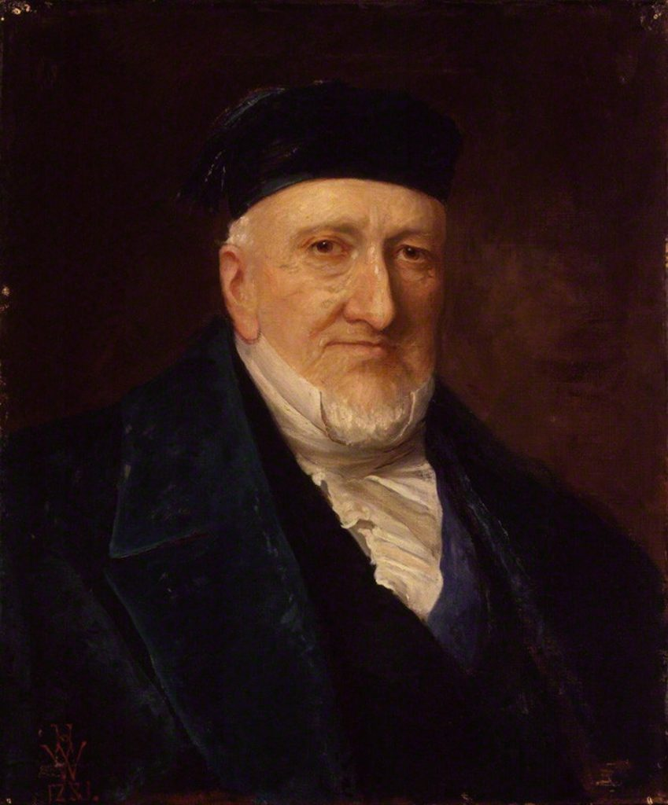](https://jewishaction.com/content/uploads/2021/11/HX5KJN.jpg)

**Oil portrait of Moses Montefiore by Henry Weigal, 1881. Montefiore was widely regarded as an international hero among Jews for his efforts in saving Damascus Jews during a blood libel. Illustration: Alamy Stock Photo**

**FG: What does shtadlanut look like in the twenty-first century? How has it evolved over the past eighty years or so?**

**DHA:** Notable in the mission statement cited above is the additional element of advocating to “the broader public.” The big change in shtadlanut in the modern era is the recognition that the twentieth century requires Jews to explain themselves not only to those who hold power, but to the world as a whole.

**New Global Role Evolves**

This is especially true in the age of the Internet, as globalization has increased dramatically and as power, in many ways, has become far more diffuse than ever before. At the turn of the twentieth century, the notoriously anti-Semitic Viennese leader Karl Lüger could silence critics who took him to task for responding positively to shtadlanut by saying, “I’ll be the one who decides who is a Jew.”

Jewish communities today cannot safely rely on shtadlanim effecting back-room deals as they might have done in the medieval era. Advocacy requires a firm commitment to ethical conduct in a political world that does not always value anything other than expediency, profit and power.

With the establishment of the State of Israel, shtadlanut took on an entirely new level, advocating for Jews around the world, such as Golda Meir’s remarkable role as an official of Israel in the former Soviet Union in 1948, or Jewish officials advocating for Ethiopian Jewry leading up to Operation Moses.

**FG: Finally, are there any women who filled this role in their communities?**

**DHA:** Historically, women have rarely played the role of official shtadlanim, as they have seldom been recognized as communal leaders. Exceptions to the rule were women who were connected to powerful men, such as Queen Helena of Adiabene, a region in what was once Assyria.

**A Few Prominent Examples**

A first-century convert to Judaism, she leveraged her position in the royal house to shape foreign aid to Jewish communities in the Land of Israel. Two other fascinating examples would be Dona Gracia Nasi and Benvenida Abravanel, two unusually powerful women in the sixteenth century who utilized their wealth and family standing to persuade various countries to open up cities of refuge for the recently expelled Jews of Spain and Portugal.

Gracia Nasi in particular asserted her leadership by organizing a boycott of the port of Ancona after Pope Paul IV cruelly burned twenty-five Jews at the stake.

Since the nineteenth century, there has been an explosion of

women’s involvement in shtadlanut [secular women], at first in terms of specifically women’s issues, like Bertha Pappenheim’s heroic attack on human trafficking in the early twentieth century, and increasingly as advocates for Jews as a whole.

\* Editor’s note: In 1858, officers of the Inquisition arrived at the Mortara residence, a Jewish family in Bologna, Italy, and took Edgardo, their young child. Edgardo had been secretly baptized when he was a baby by the family nanny, who was Catholic. According to papal law, the child was considered a Catholic who must be educated by the Church. The “Mortara case” spurred a wave of protests, with pressure from Europe and the US on Pius IX to return the child. He refused. Edgardo eventually became a priest, but the kidnapping, which became an international scandal, set in motion far-reaching political ramifications.

Faigy Grunfeld teaches English and history. She lives in Detroit, Michigan, with her family.

Reprinted from the Winter 2022 edition of Jewish Action, the OU (Orthodox Union) magazine.

